Lab - Using VS Code with GitHub
In this Lab Exercise, you’ll be provided with a step-by-step guide on how to download and install GitHub along with adding a GitHub Repository to Visual Studio Code (VS Code) on your Windows 10 Operating System.
- Open the following “GitHub” Download Link in a Web Browser. Select the “Windows” Version in the “Downloads” Box. (https://git-scm.com/downloads)
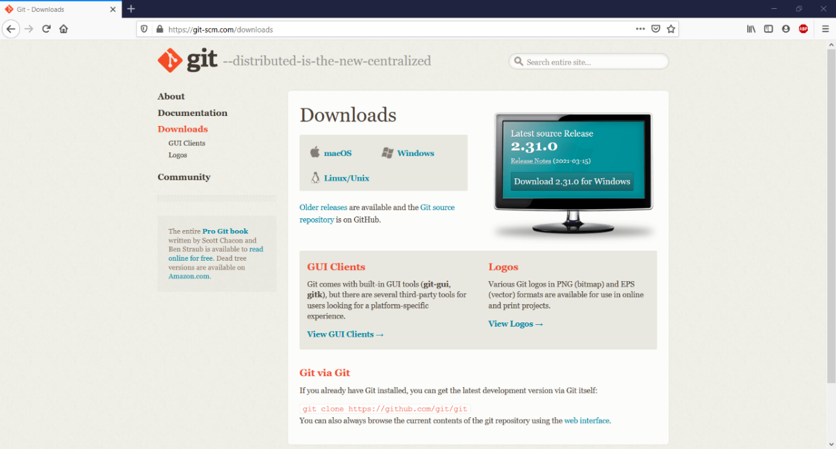
- Click on “Save File” in the “Git-2.31.0-64-bit.exe” Pop-Up Window. Once the Download is Completed, the “Git-2.31.0-64-bit.exe” Installation File will appear in the “Downloads” Folder.
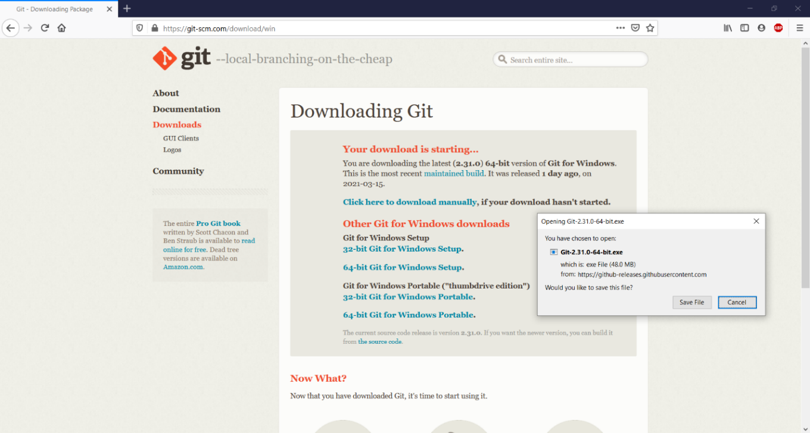
- Double-Click on the “Git-2.31.0-64-bit.exe” Installation File in the “Downloads” Folder on your system. The “Git-2.31.0” Setup Wizard will appear. Click on “Next” to Continue.
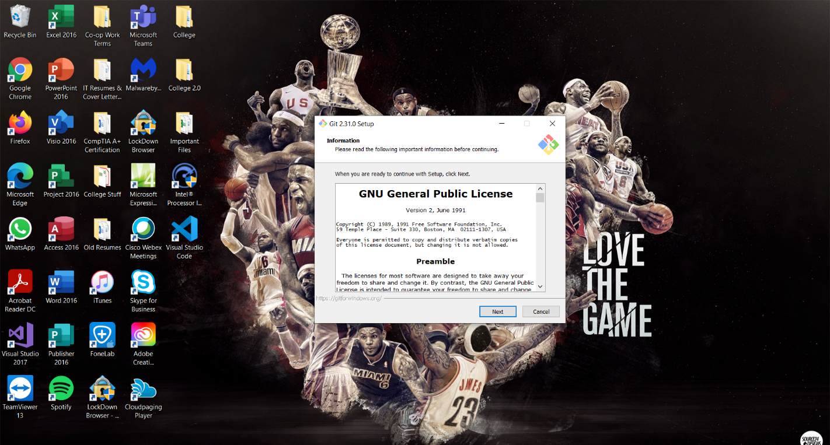

- Click on “Next” to Install “GitHub” to the “Default” Destination Folder or Click on “Browse” to Choose a Custom “File Path” Directory. Click on “Next” to Continue.
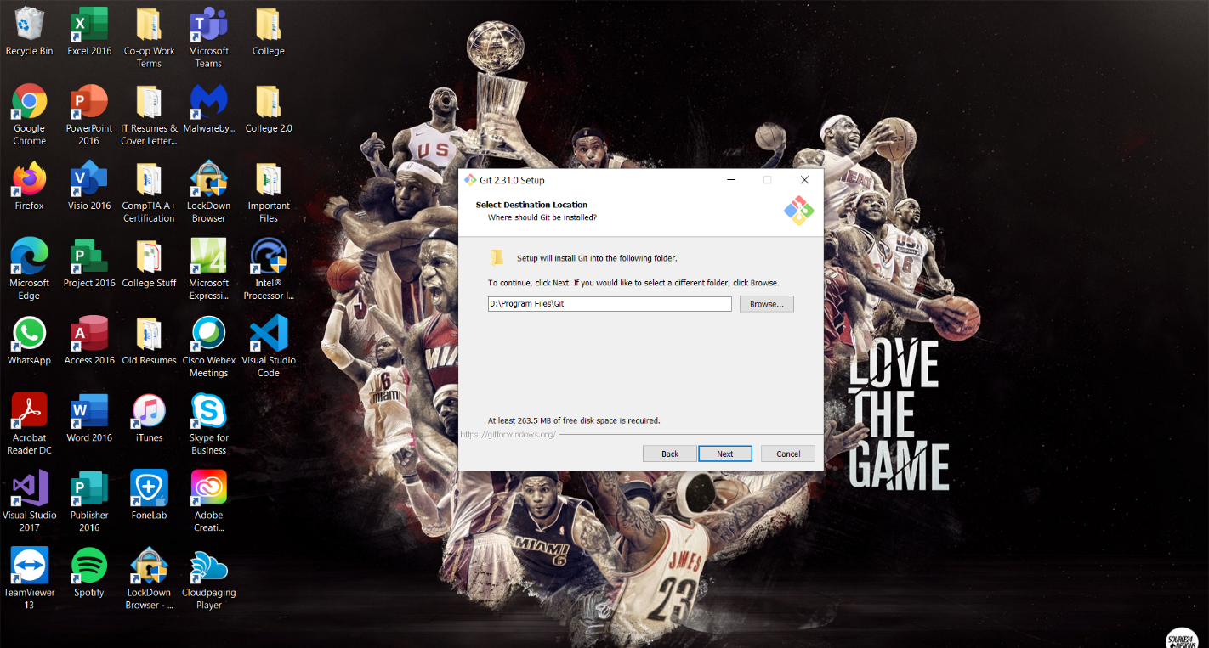

- Click on “Next” to Continue. (Keep Default Selections)
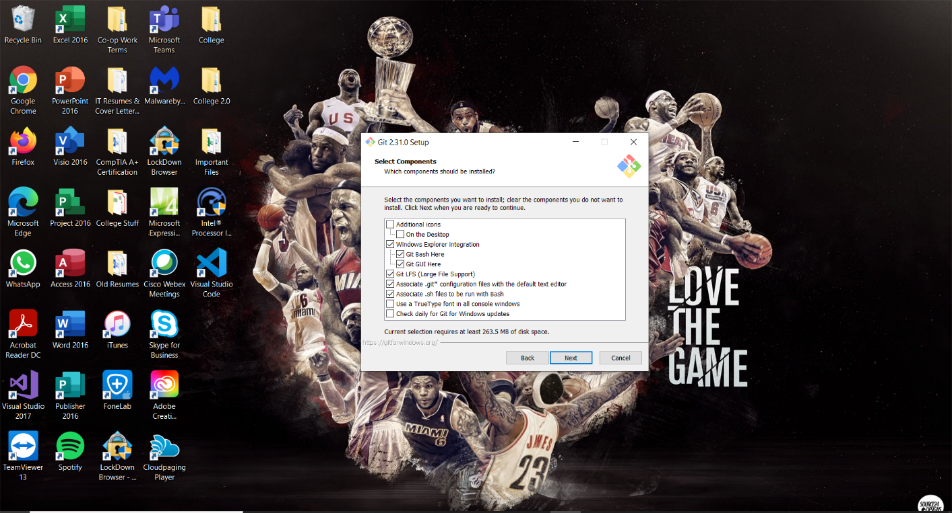

- Click on “Next” to Create a Shortcut for “GitHub” in the “Default” Start Menu Folder or Click on “Browse” to Choose a Custom “File Path” Directory. Click on “Next” to Continue.
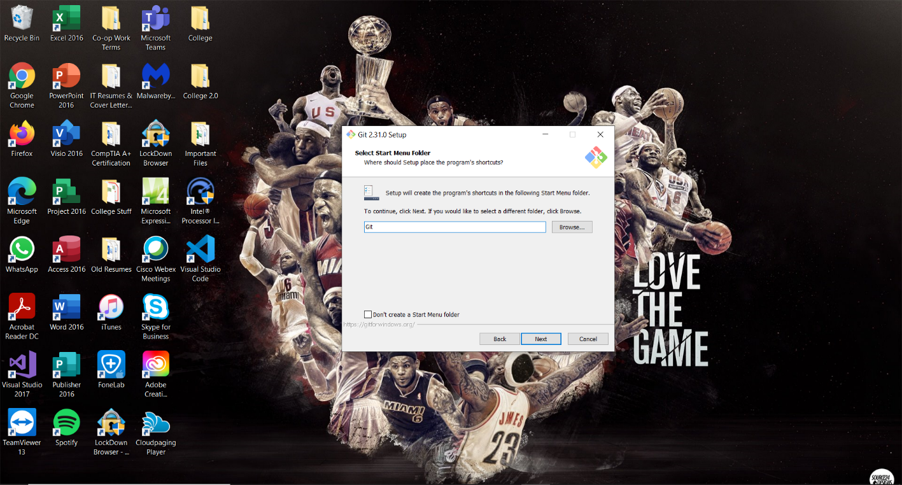

- Select the “Use Visual Studio Code as Git’s Default Editor” Drop-Down Menu Option. Click on “Next” to Continue.
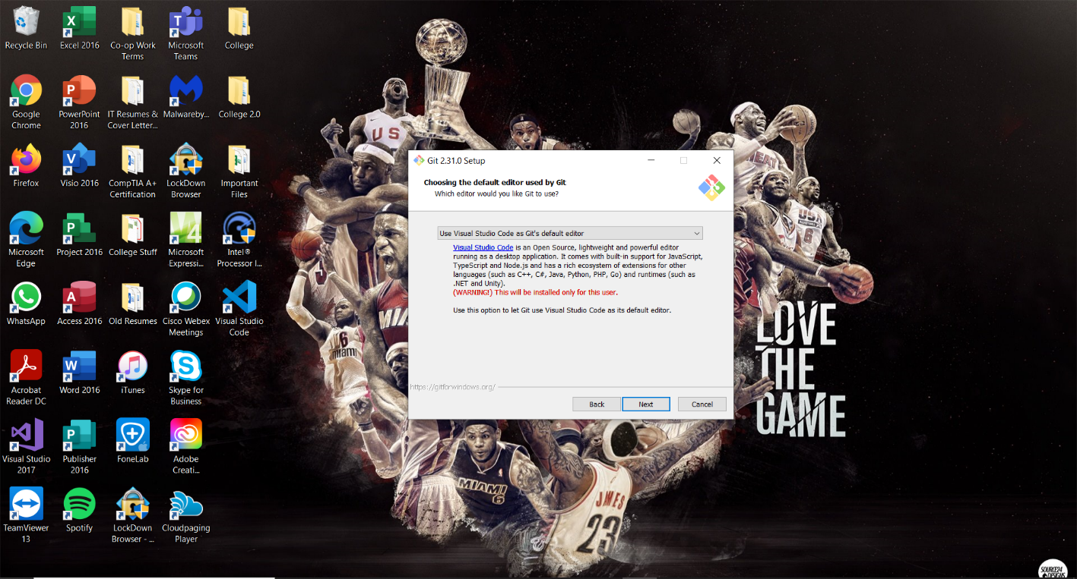

- Click on “Next” for all the “Git-2.31.0” Setup Wizard “Settings” options until you appear on this screen. Click on “Install” to Begin the Installation for “Git-2.31.0”. (Keep Default Selections)
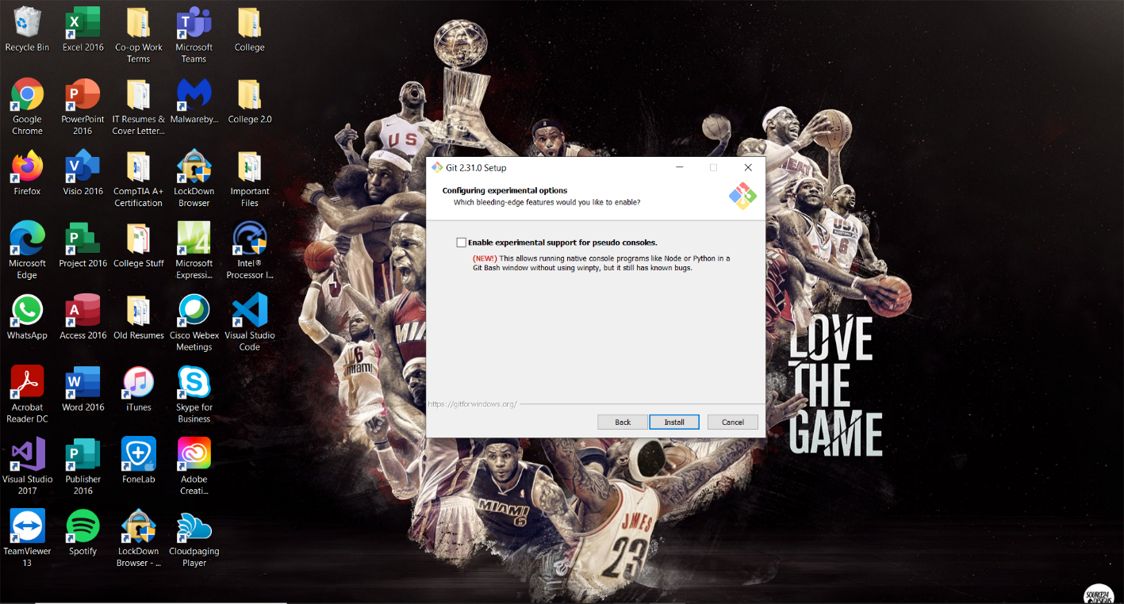

- Wait for the “GitHub 2.31.0” Installation to be Finished.
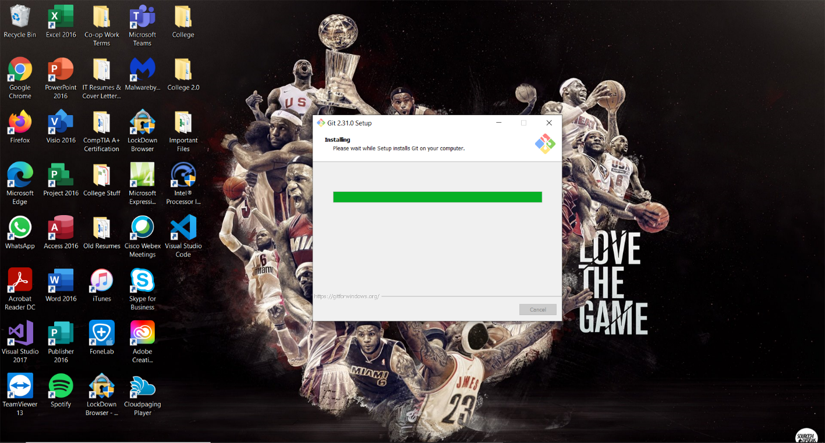

- Once the Installation is Finished, Click on “Finish” to Exit the “GitHub 2.31.0” Setup Wizard.
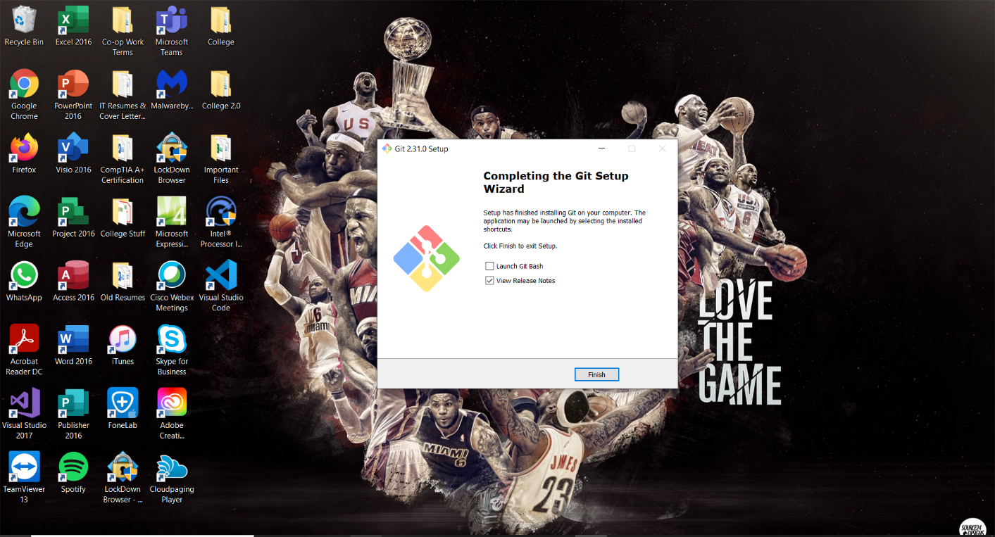

- Open the following “GitHub” Sign-Up Link in a Web Browser. Click on the “Sign- Up” Button in the Top-Right Corner. (https://github.com/)


- Create a New “GitHub” Account”. Once finished filling out the “Username”, “Email Address”, and “Password” Account Credentials, Click on “Create Account” to Continue.
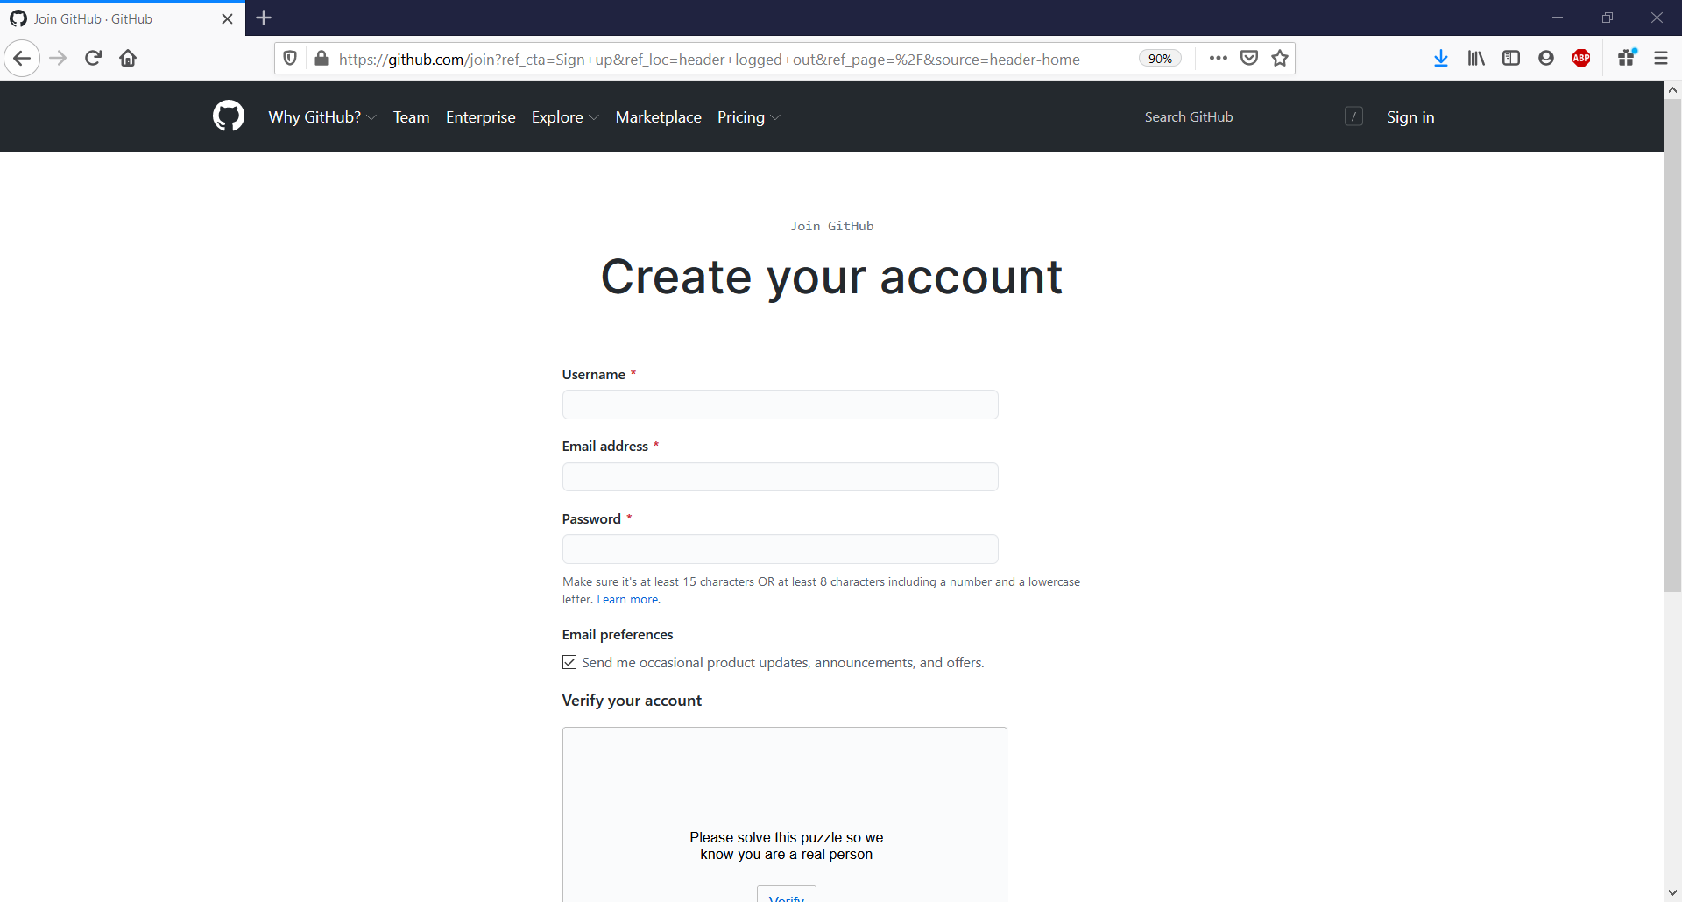

- Sign-In to the Created “GitHub” Account”. Click on “Create Repository” on the Left Pane under “Create your First Project”.
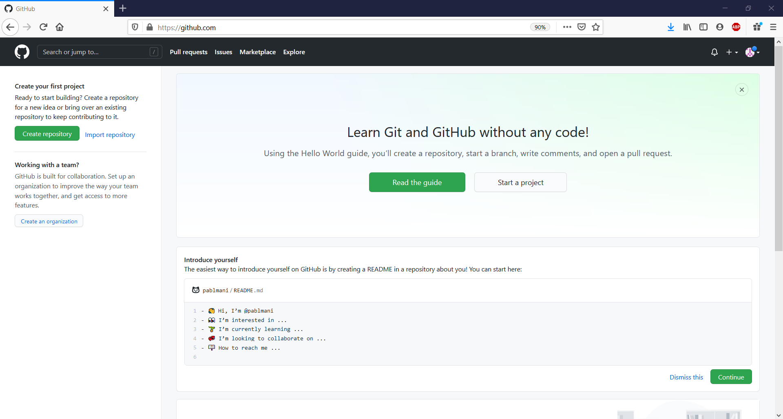

- Enter “PowerShell_Script” under “Repository Name” and Select the “Public” Radio Button option. Once Finished, Click on “Create Repository” to Continue.
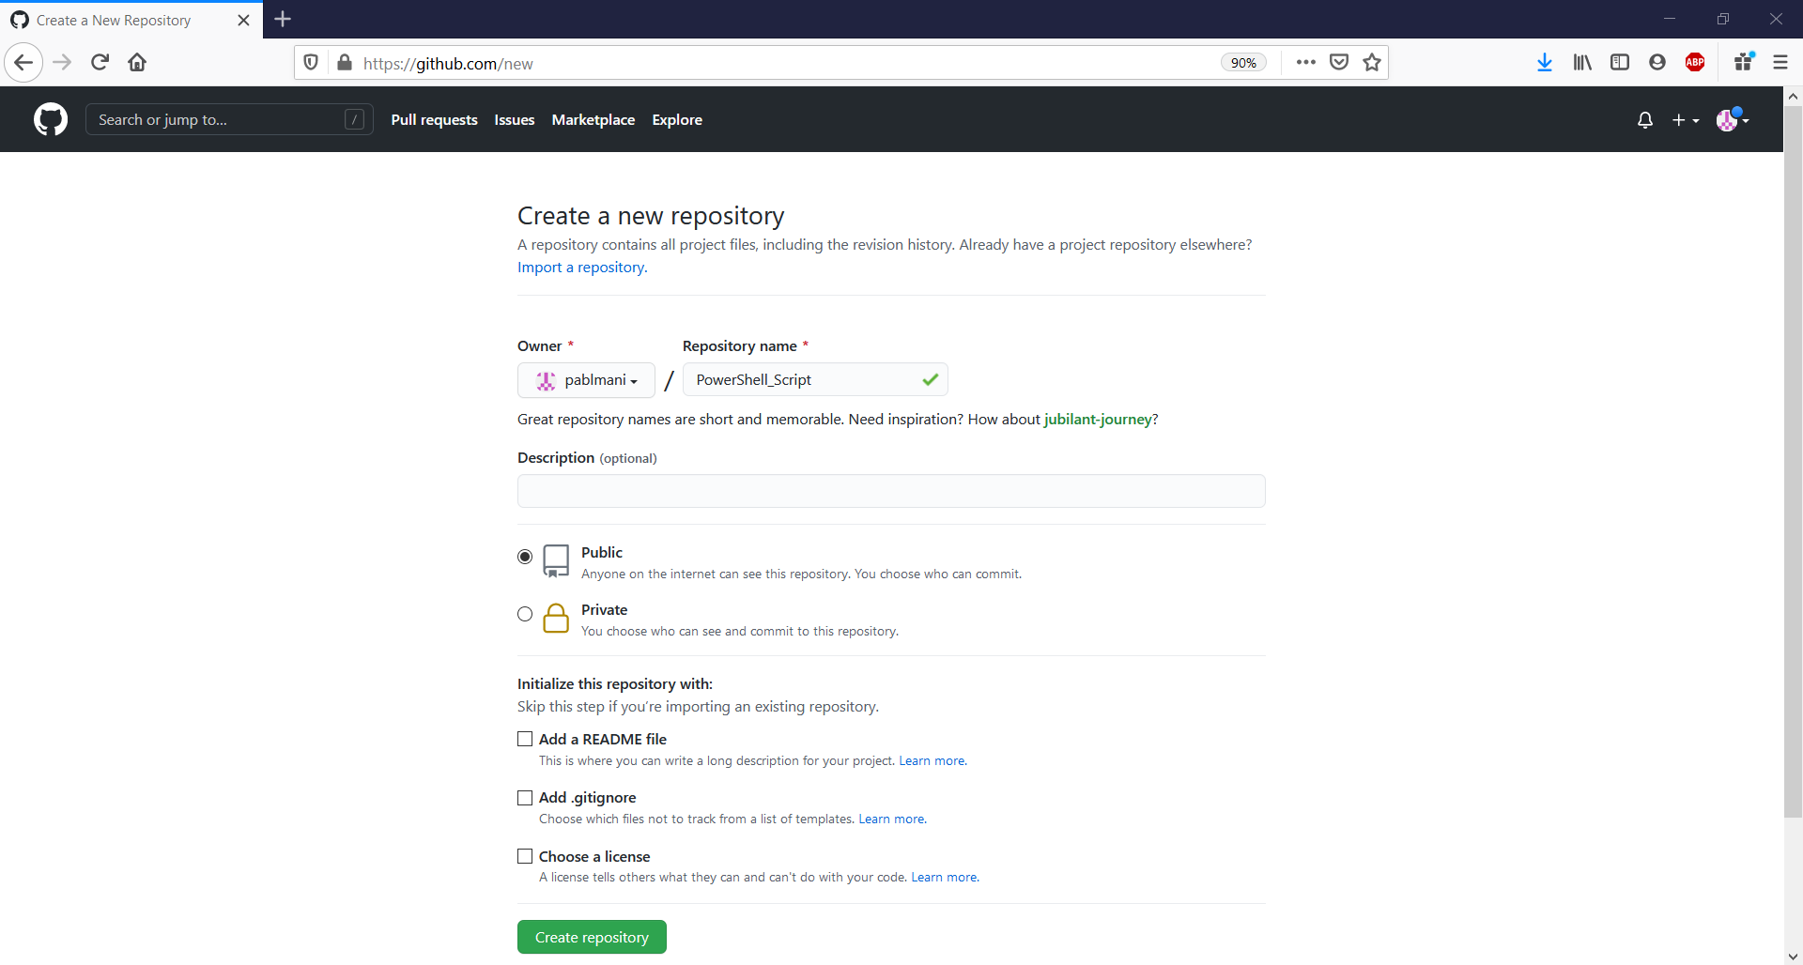

- Copy the “HTTPS” Link to the Created “Repository”.
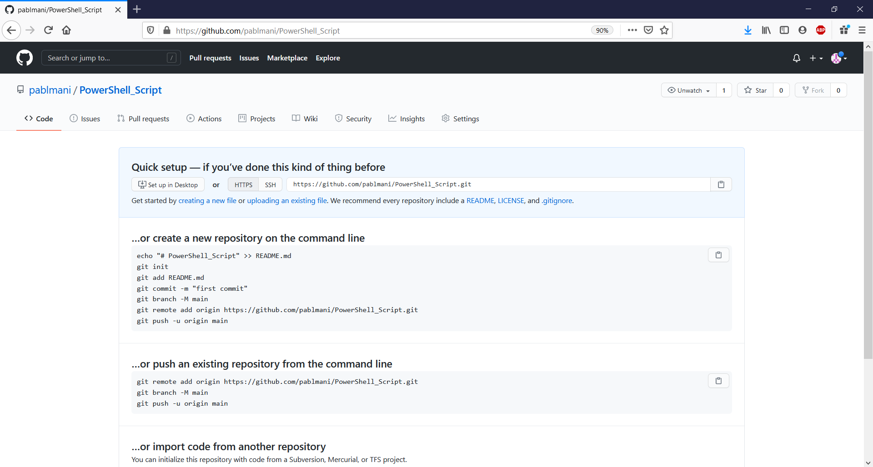

- Open “Visual Studio Code” also known as “VS Code” and Click on the “Settings” Icon in the Bottom-Left Corner of the “Toolbar Menu”. Type in “Git-Enabled” in the “Settings” Search Bar to Ensure if the “Checkbox” is “Marked”.
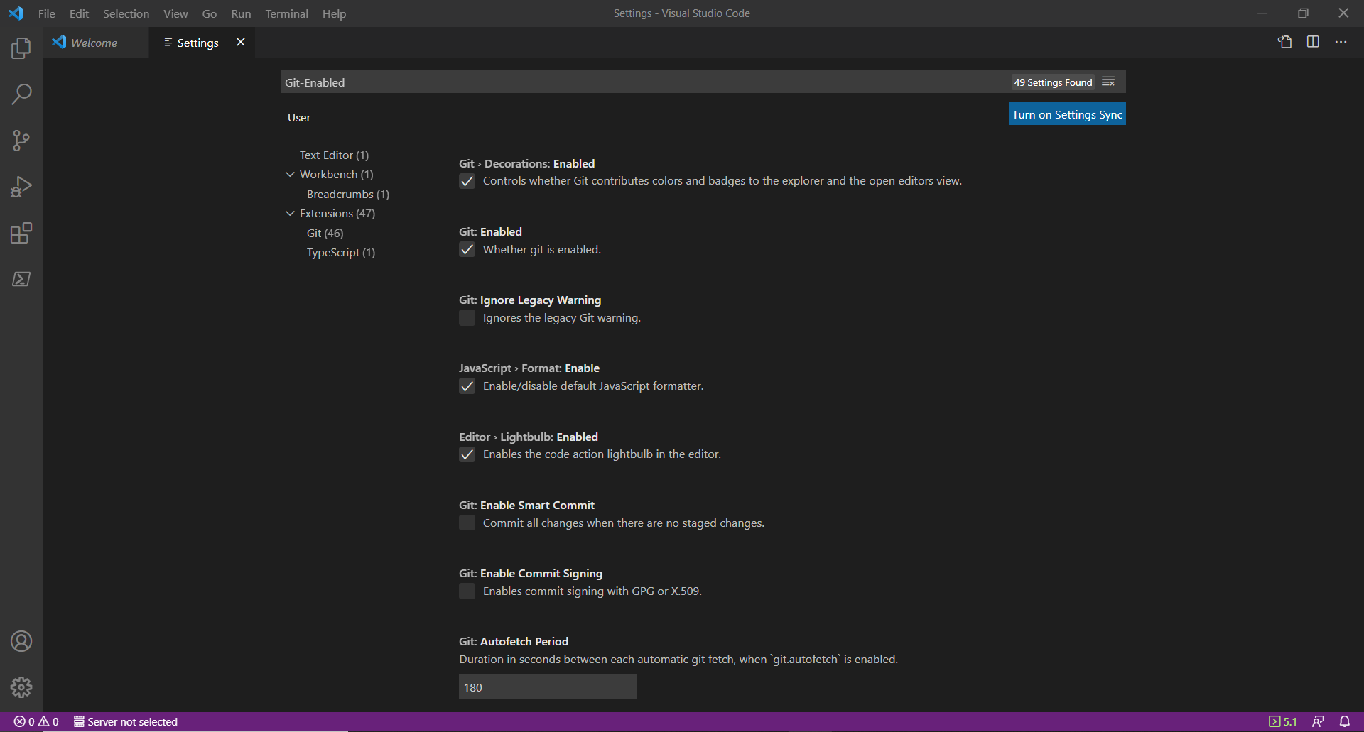

- On the Left “Toolbar Menu”, Click on the “Extensions” Icon. Type in “GitHub Pull Requests and Issues” in the “Extensions” Search Bar and Click on “Install”. Once it’s been Installed, you’ll be able to view the “GitHub” Icon on the Left “Toolbar Menu”.
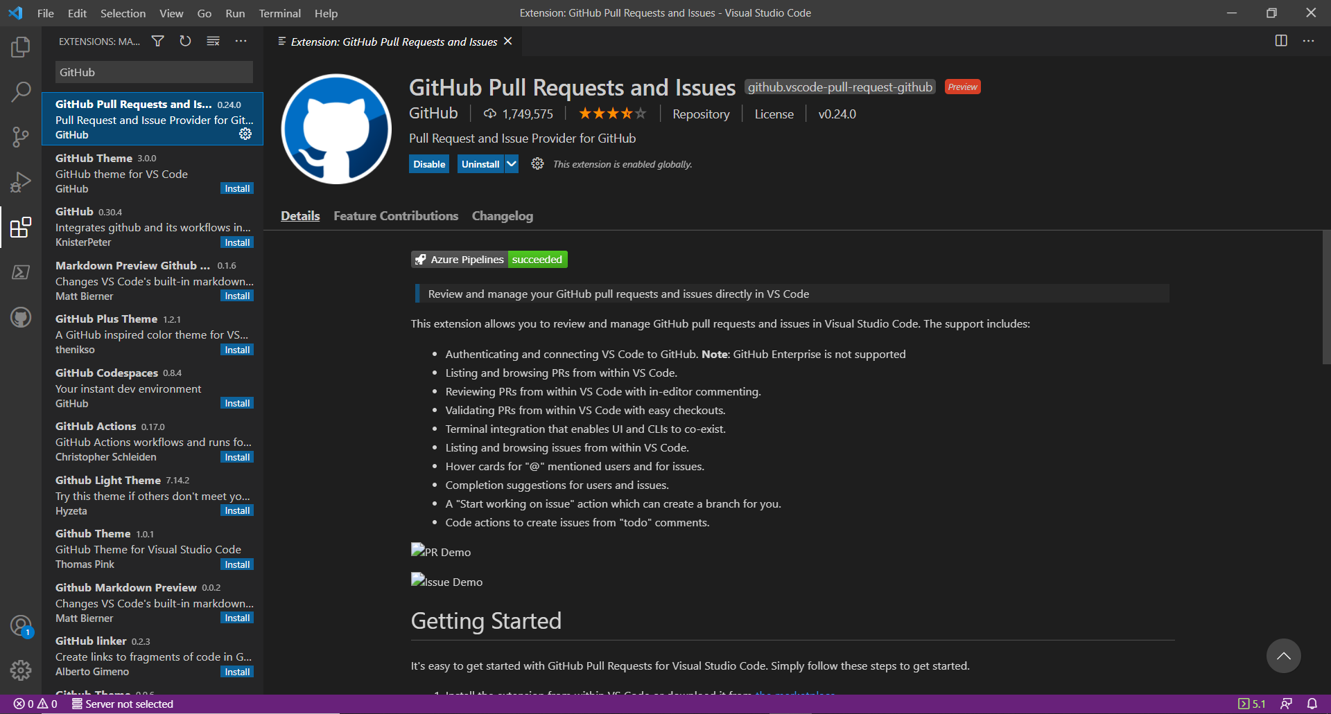

- On the “VS Code” Welcome Window, Click on “Clone Repository” under the “Start” Menu.
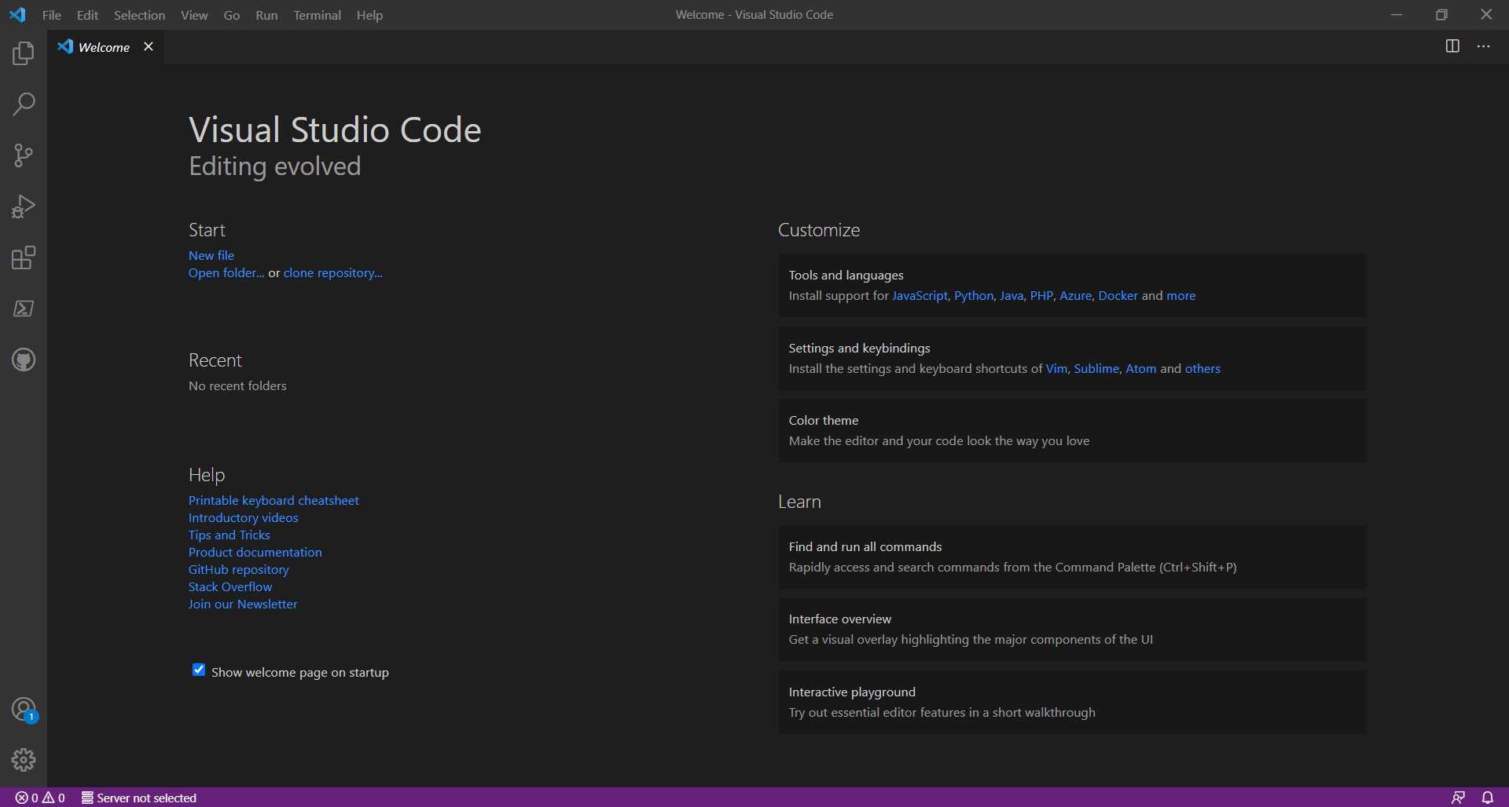

- Click on the “Clone from GitHub” Drop-Down Search Bar Option.
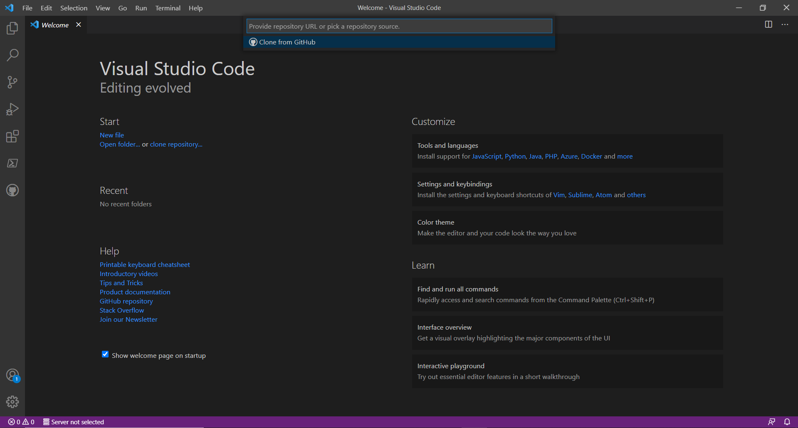

- In the “Visual Studio Code” Pop-Up Window, Click on the “Allow” Button.
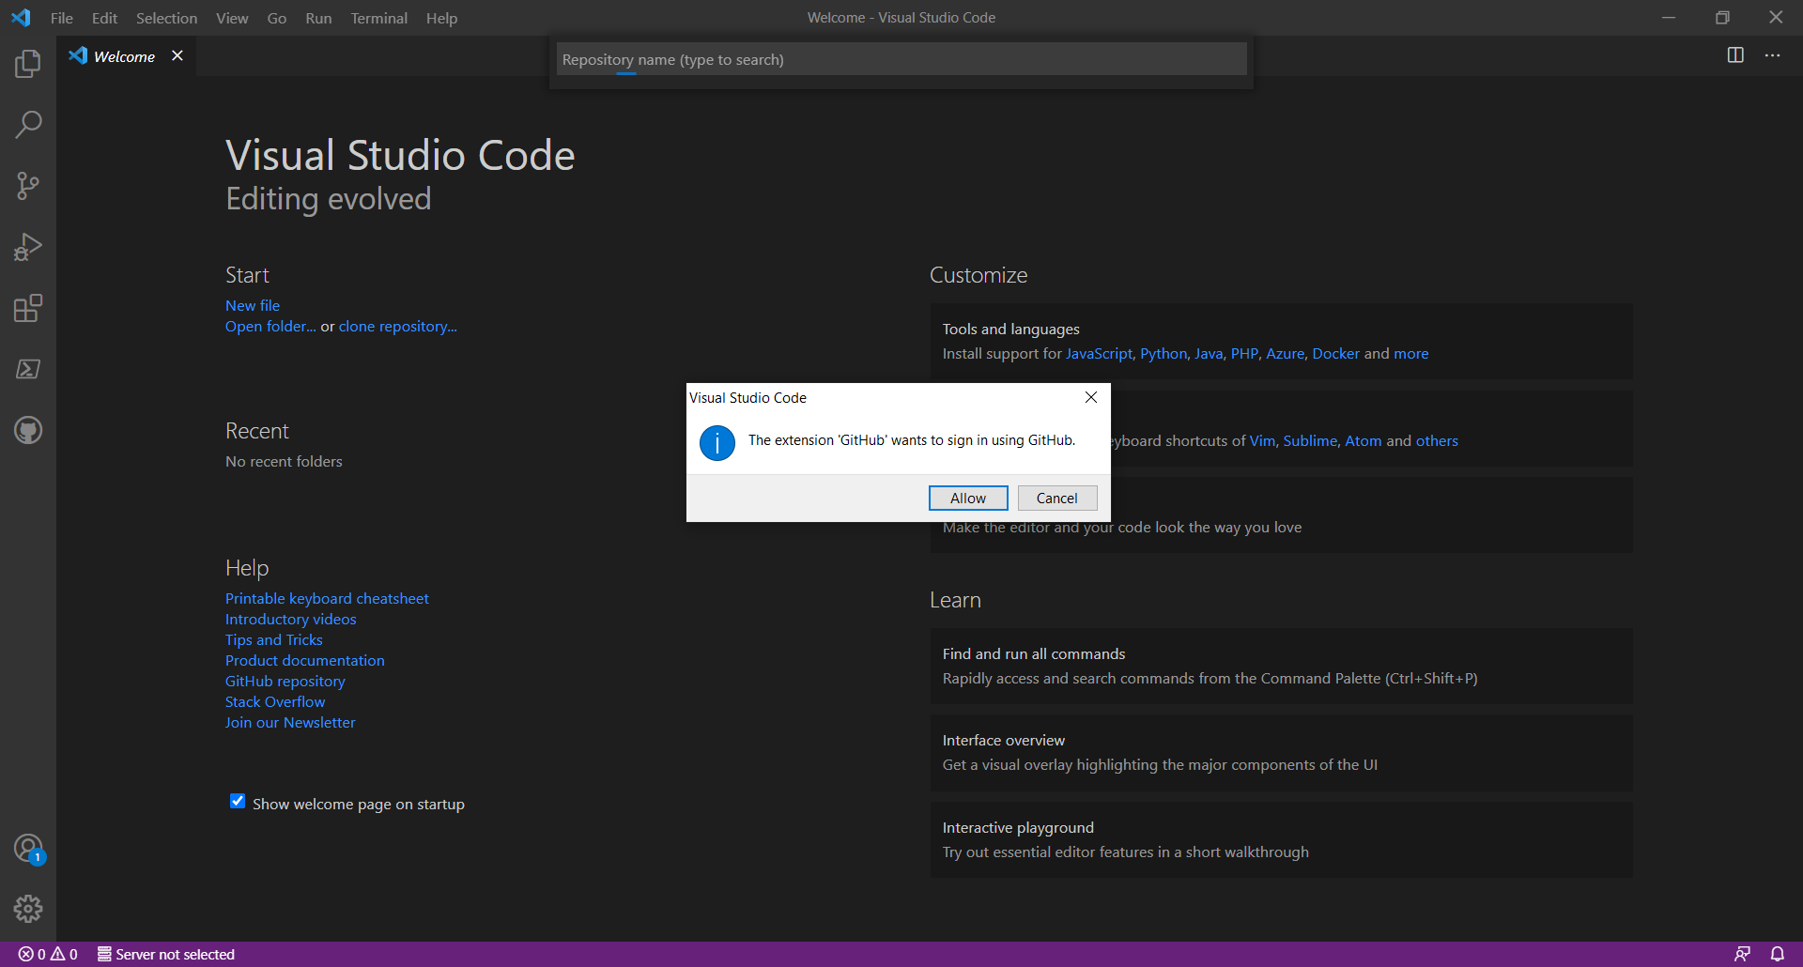

- Once it Redirects you to this “Authorize Visual Studio Code to Access GitHub” Web Page, Click on the “Continue” Button.
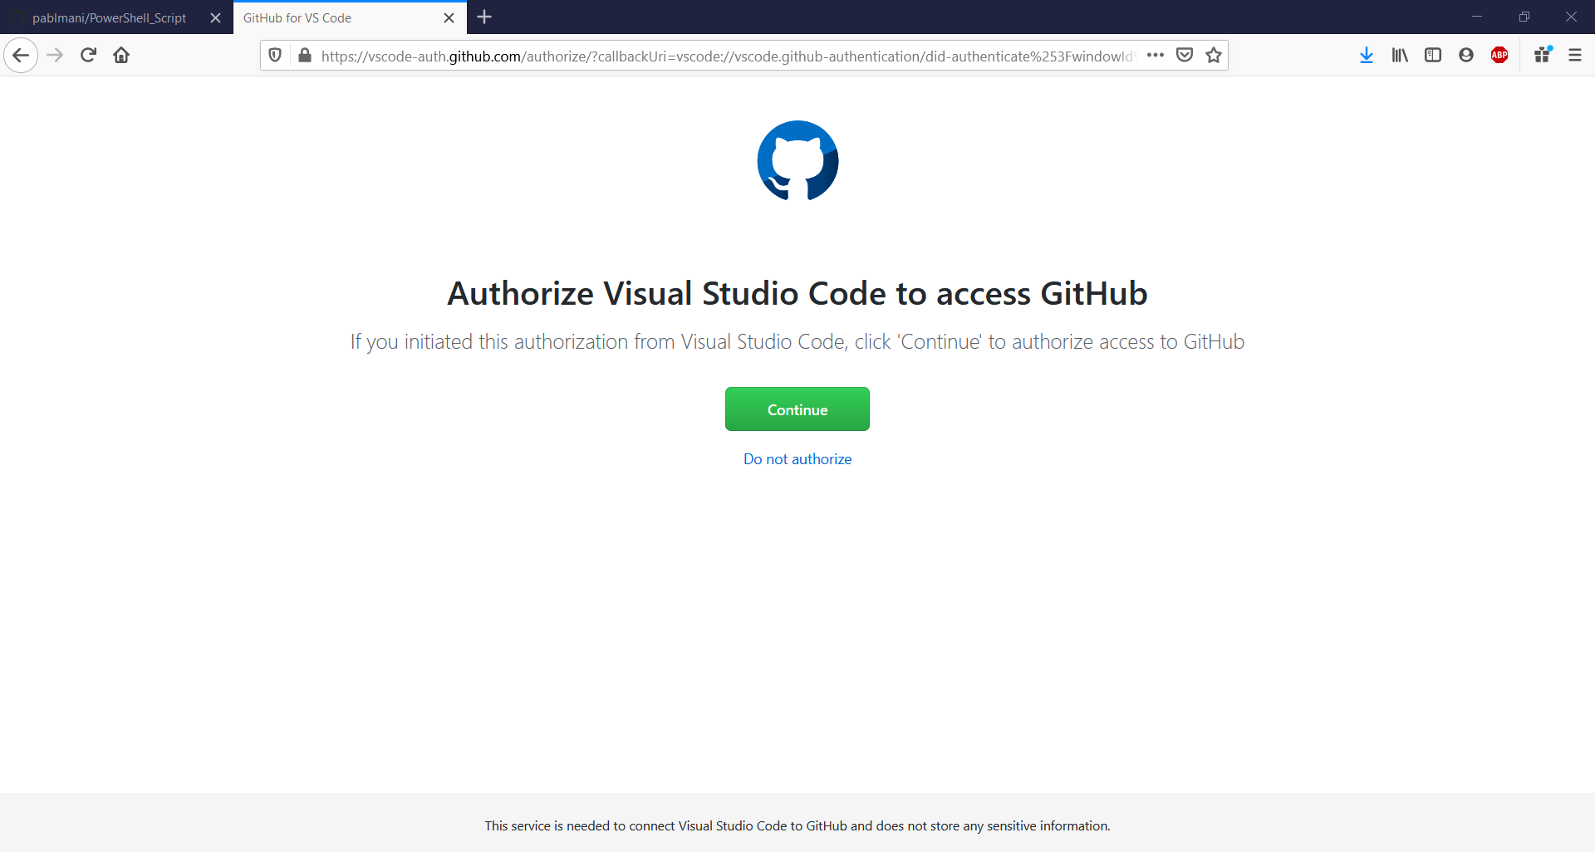

- On this “Authorize GitHub for VSCode” Page, Click on the “Authorize GitHub” Button.
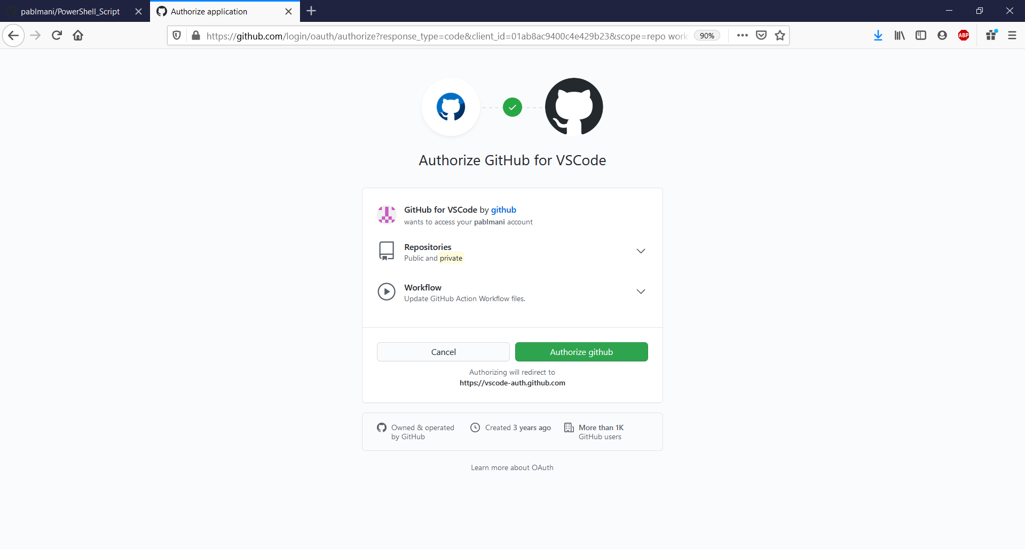

- Mark the “Always allow https://vscode-auth.github.com to open vscode links” Checkbox and Click on the “Choose Application” Button.
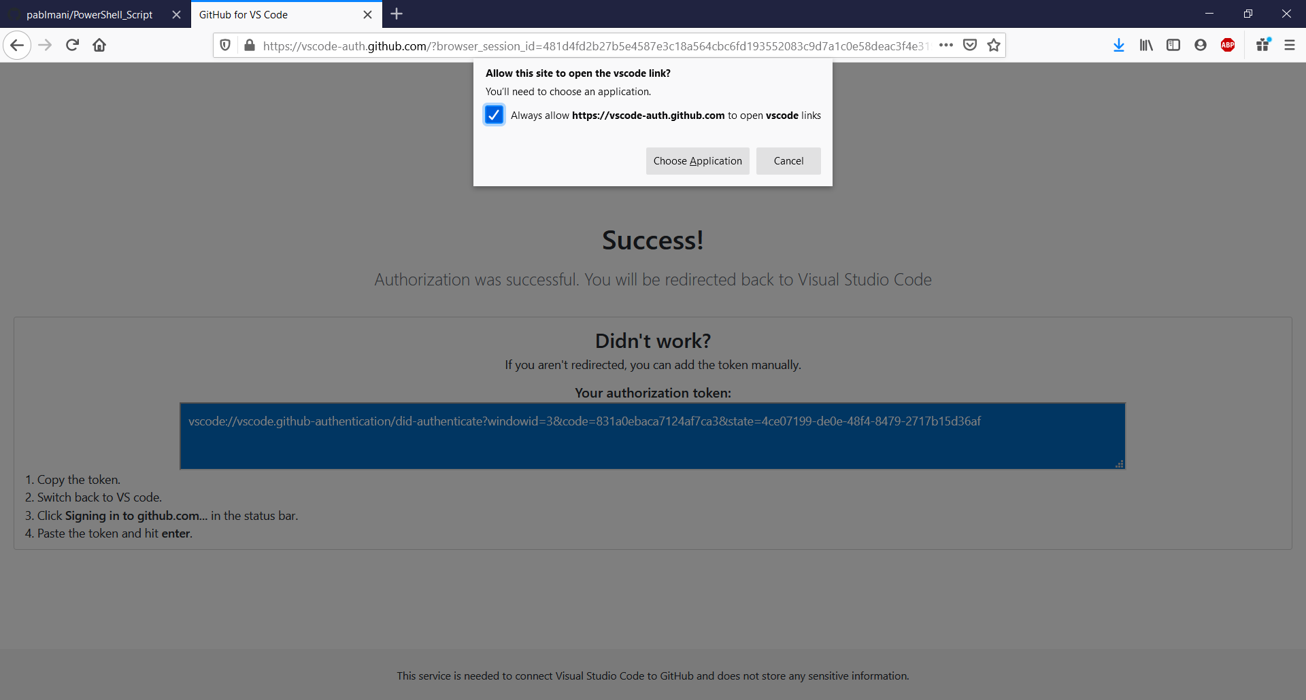

- Select the “Visual Studio Code” Application and Click on the “Open Link” Button.
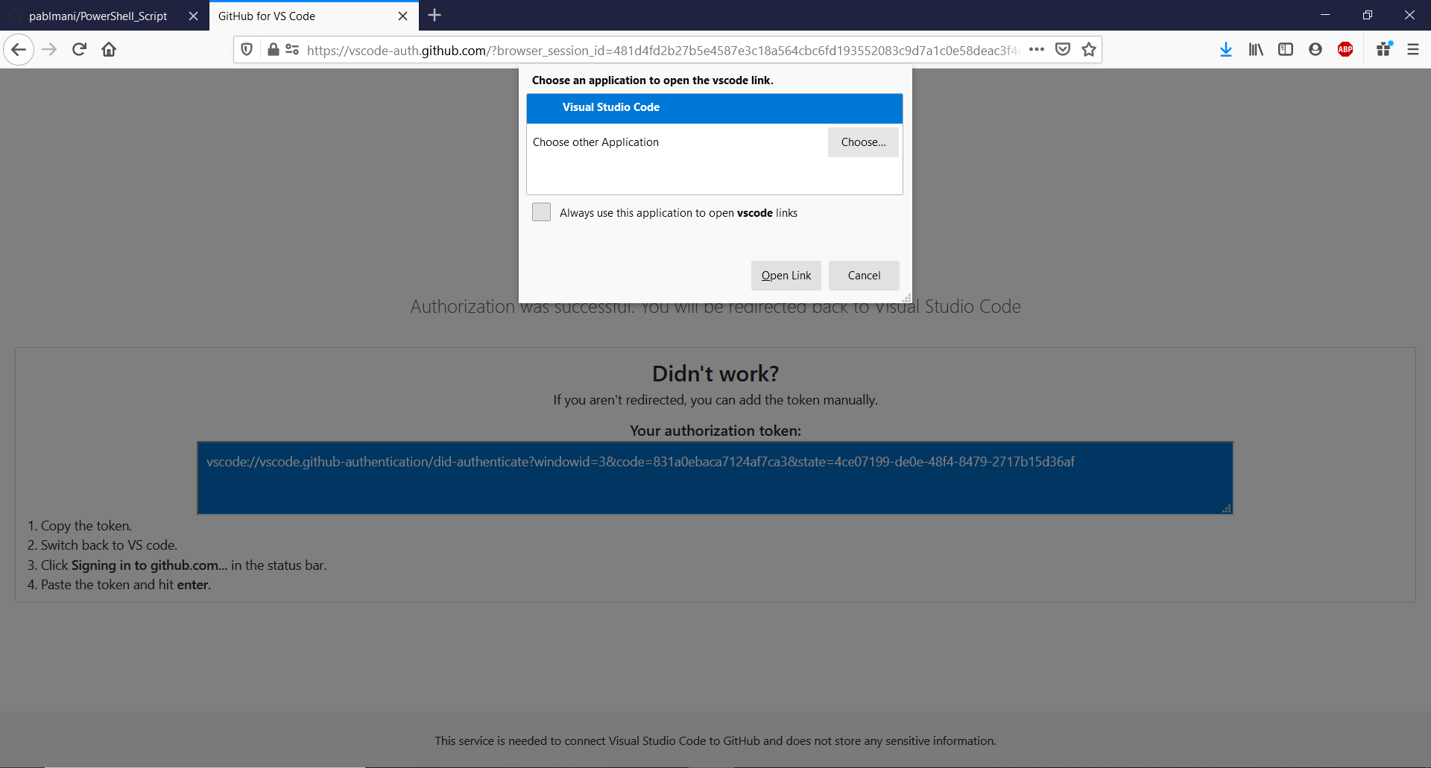

- In the “Visual Studio Code” Pop-Up Window, Click on the “Open” Button to allow an Extension to Open the “GitHub Authentication” URL.
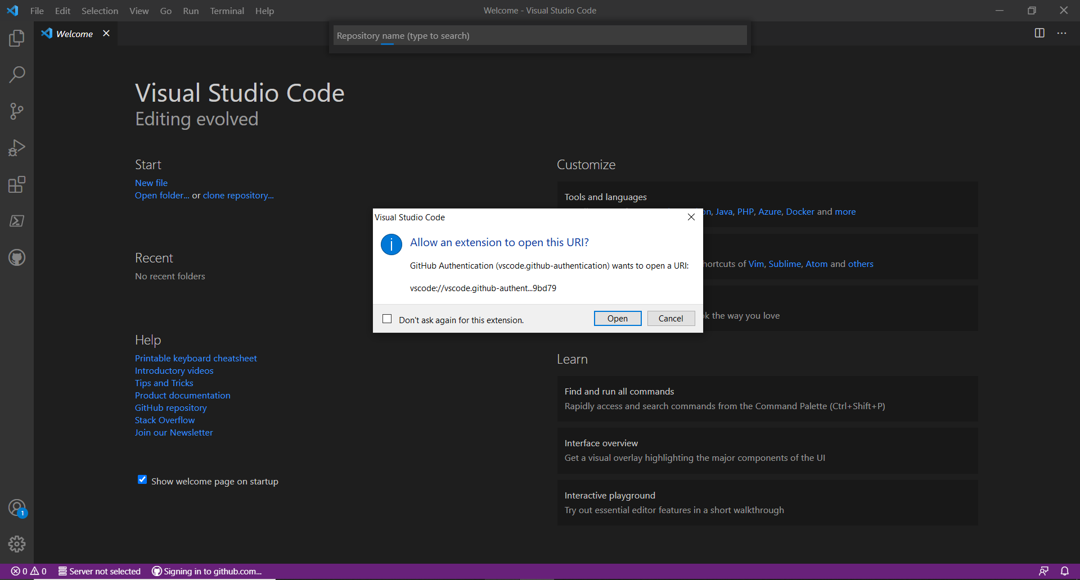

- Select the “pablmani/PowerShell_Script” Repository in the Drop-Down Search Bar that you previously created on the “GitHub” Web Page.
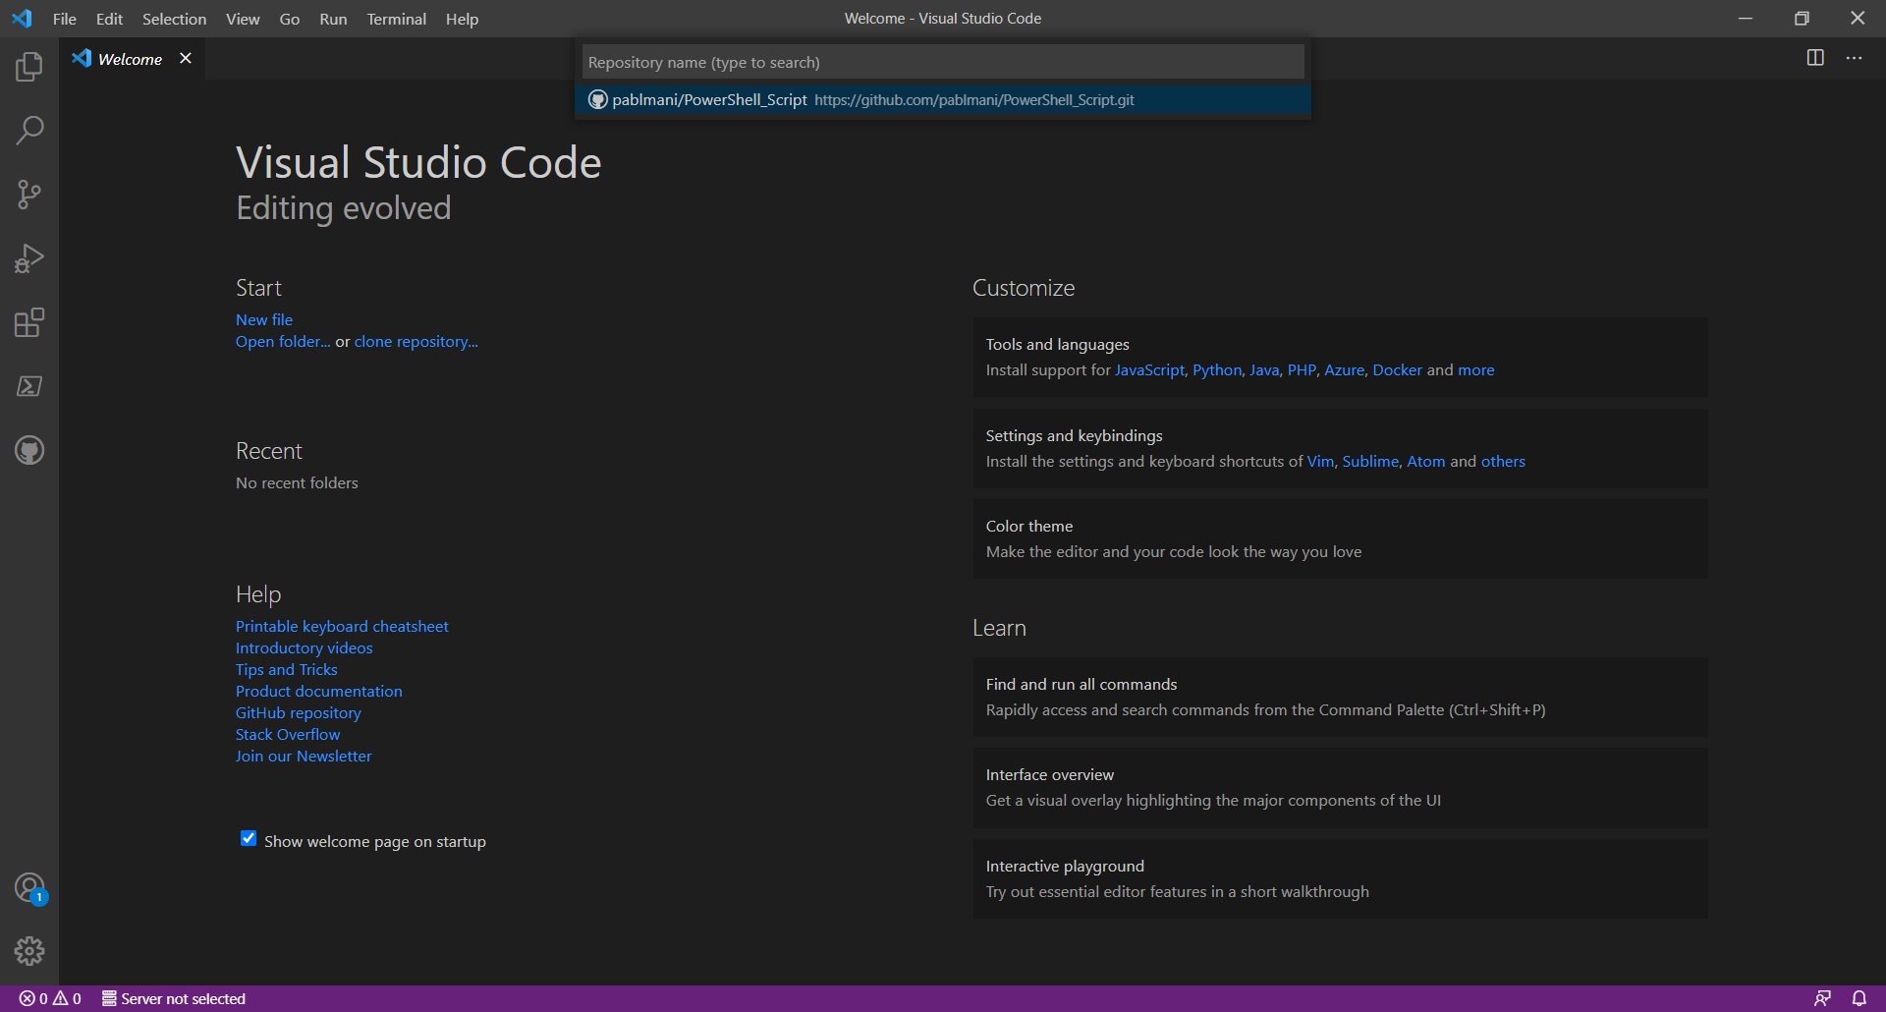

- Select the “Script” Destination Folder as the “Repository Location”.
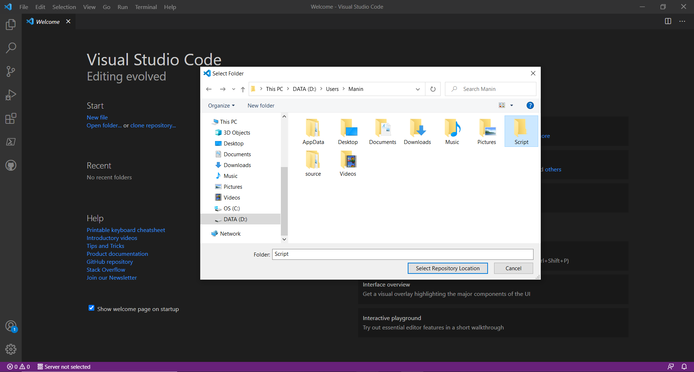

- Click on the “Accounts” Icon in the Bottom-Left Corner of the “Toolbar Menu” to Verify if you’re Signed-In to your “GitHub” Account.
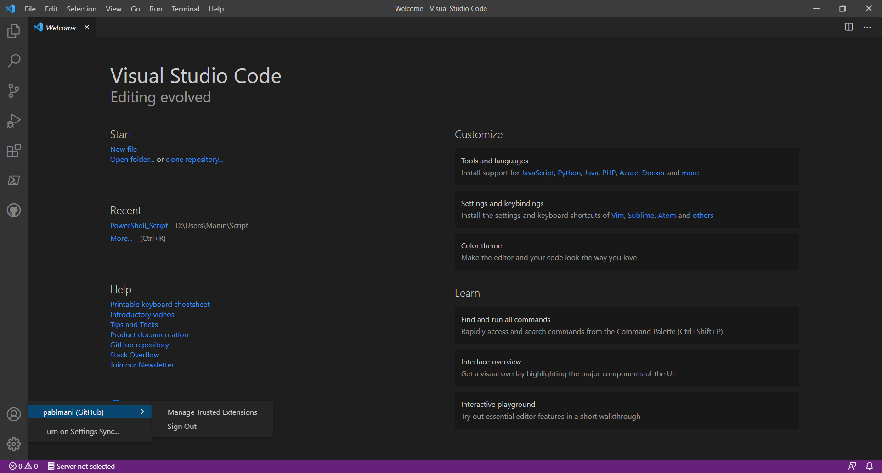

- Click on “File” and “Open Folder” in the Top “Toolbar Menu”. Navigate to the “MyFirstScript.ps1” PowerShell File and Click on the “GitHub” Icon in the Left “Toolbar Menu”.
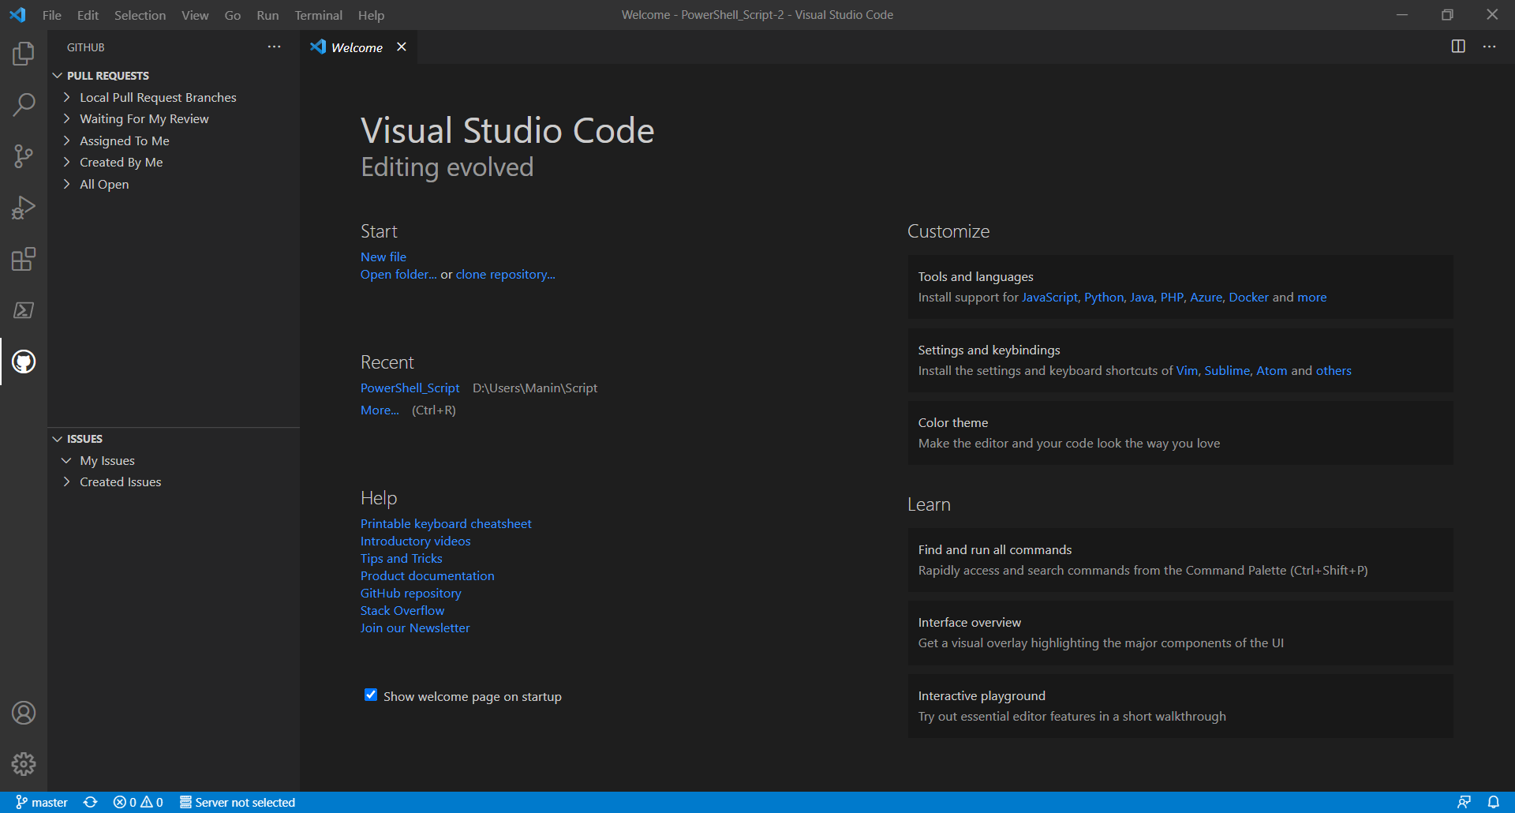

- Open the “Script” Destination Folder that was chosen as the “Repository Location” and Verify if there’s a “New Folder” created inside called “PowerShell_Script” based on the “Repository Name”. Drag the “MyFirstScript.ps1” PowerShell File over to the “PowerShell_Script” Repository Folder. Open the “MyFirstScript.ps1” PowerShell File on “VS Code” from the “PowerShell_Script” Destination Folder and Expand the “Source Control” in the Left Pane.
